Lab Number: | 7
S tudent Name: | Rishi Rameshkumar Dubey
Roll No : | 29

Title:

- To write a program to demonstrate friend function in C++.
- To write a program to demonstrate friend class in C++.

Learning Objective:

- Students will be able to implement friend function and friend classes in C++.

Learning Outcome:

- To understand how to use the private members using friend function and friend class.

Course Outcome:
Percept the Utility and applicability of OOP
ECL304.6

Theory:
- Explain in details about access specifiers: public, private and protected.

C++ offers the possibility to control access to class members and functions by using access specifiers. Access specifiers are used to protecting data from misuse.
Public Specifier
Public class members and functions can be used from outside of a class by any function or other classes. You can access public data members or function directly by using dot operator (.) or (arrow operator-> with pointers).
Protected Specifier
Protected class members and functions can be used inside its class. Protected members and functions cannot be accessed from other classes directly. Additionally protected access specifier allows friend functions and classes to access these data members and functions. Protected data members and functions can be used by the class derived from this class. More information about access modifiers and inheritance can be found in C++ Inheritance
Private Specifier
Private class members and functions can be used only inside of class and by friend functions and classes.

- Explain about friend function and friend classes in C++

A friend function is a function that is specified outside a class but has the ability to access the class members’ protected and private data. A friend can be a member’s function, function template, or function, or a class or class template, in which case the entire class and all of its members are friends.
In special cases when a class’s private data needs to be accessed directly without using objects of that class, we need friend functions. For instance, let’s consider two classes: Director and Doctor. We may want the function gross_sa1ary to operate the objects of both these classes. The function does not need to be a member of either of the classes.
They are also used in operator overloading because they are more intuitive. The binary arithmetic operator that is commonly used can be overloaded the friend function way. Go ahead and check out operator overloading using a friend function for more information.

A friend class can have access to the data members and functions of another class in which it is declared as a friend. They are used in situations where we want a certain class to have access to another class’s private and protected members.
Classes declared as friends to any another class will have all the member functions become friend functions to the friend class. Friend functions are used to work as a link between the classes.

Algorithm | Step1:Start  Step2: Declare the class name  Step3: Declare the friend function in the class Step4: Display result.  Step5:Stop
Program: | https://github.com/KEE2120/Skill-Lab/blob/618bfdfff856aec08baf0a9495ad9b5aaa763b60/29_lab%207.docx
Input
given:

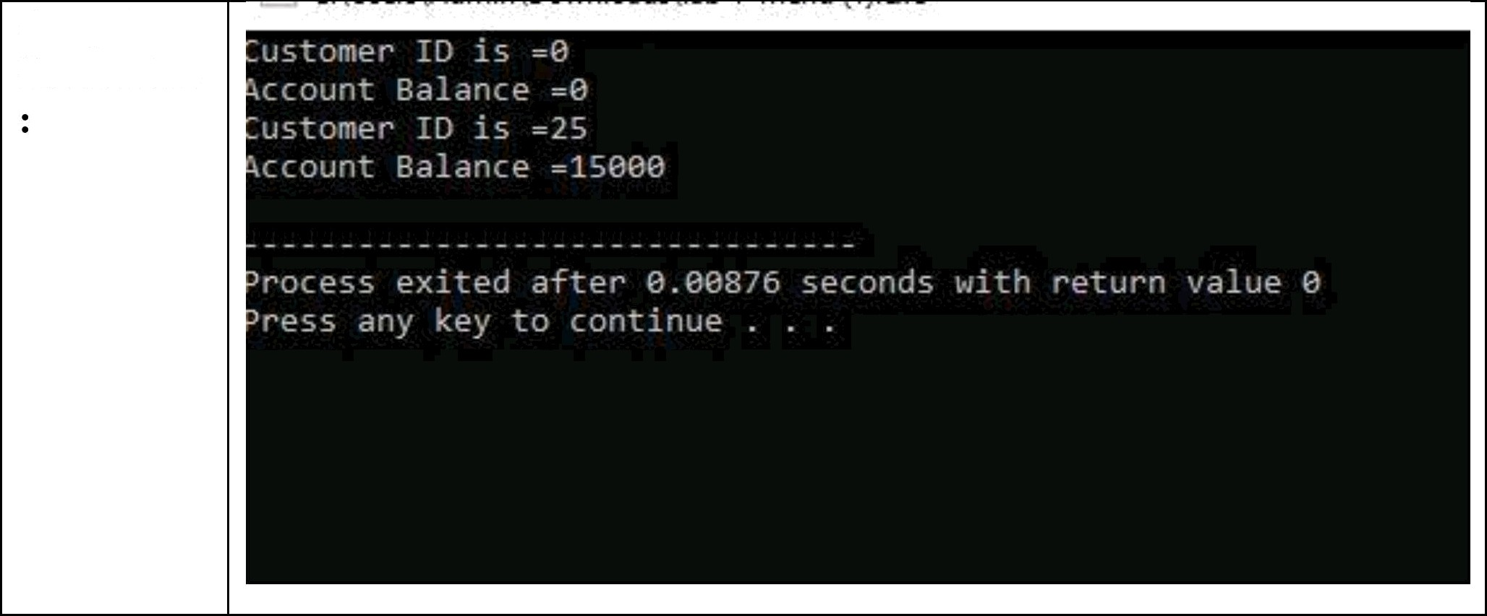
Output Screenshot

Algorithm | Step1:Start  Step2: Declare the class A and class B Step3: Declare the friend function to class B Step4: Display result  Step5:Stop
Program: | https://github.com/KEE2120/Skill-Lab/blob/618bfdfff856aec08baf0a9495ad9b5aaa763b60/29_lab%207.docx
Input:

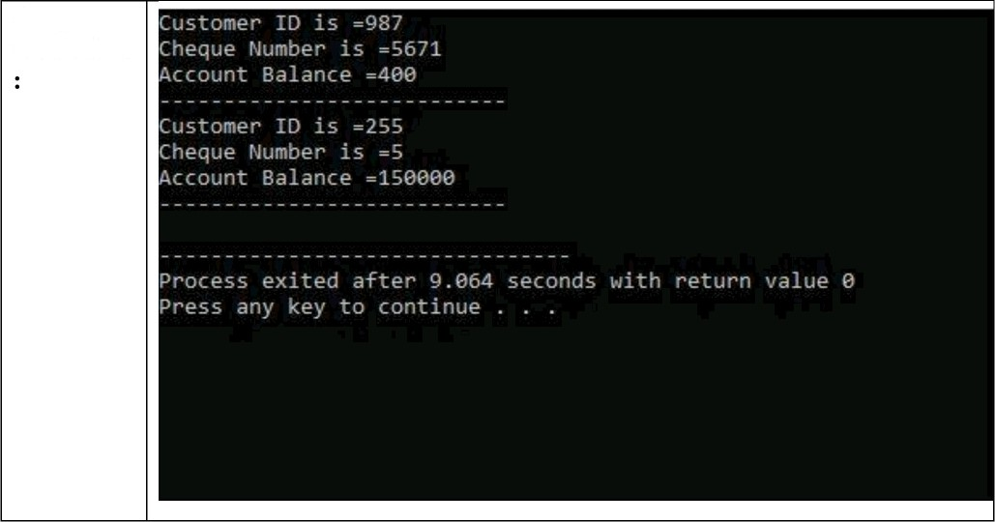
Output screenshot

